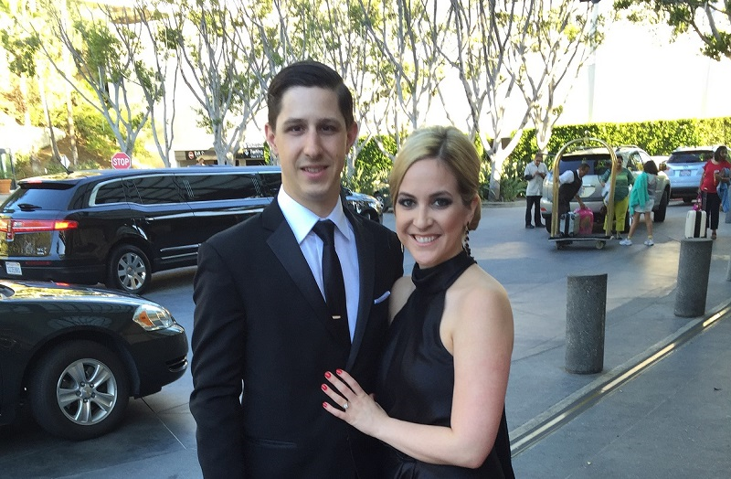

Clarissa and Curtis

October 3rd, 2015